Challenge 5 and 6: Deployed the Agent to Agent Engine and able to test in the playground
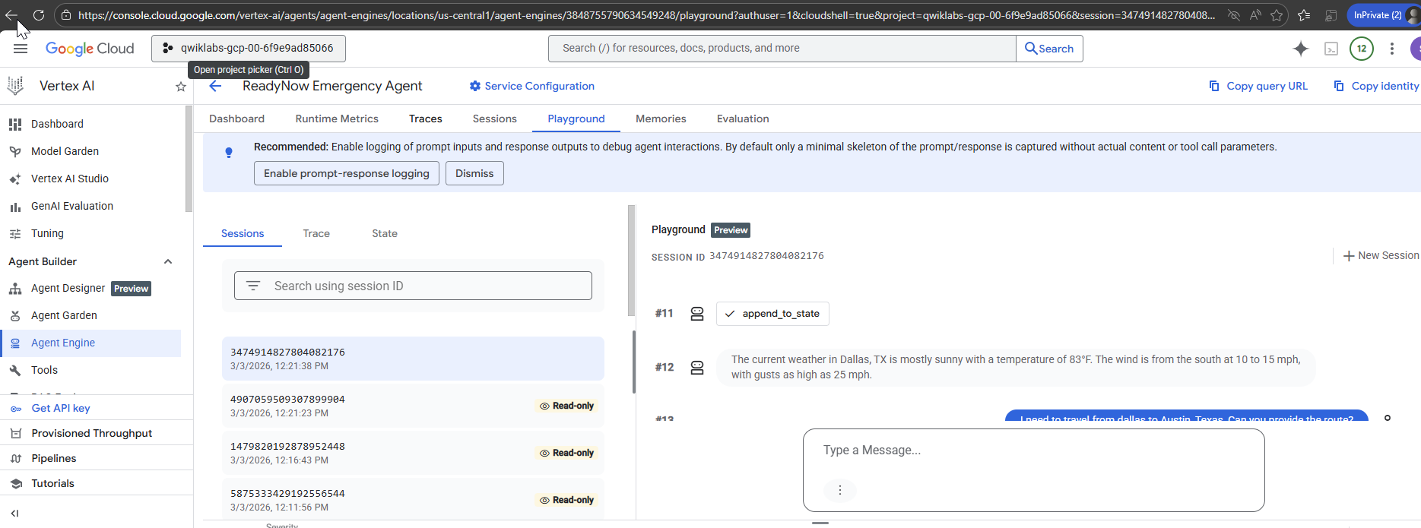

Due to permission(policy) issues with my current client, I have limitation to global search functionality

